**Supervisor – Dr Fadi Fayez**

**AMAL JOSE 180004449**

**KIRPALPREET KAUR 180002384**

**TAPAN VYAS 180003088**

MIT STUDENT HUB WEBSITE

Interactive student hub website for Manukau Institute of Technology

|  |  |
| --- | --- |
| Team Members | Work Done |
| Amal Jose | Risks and mitigations, software methodology, Research methodology Gantt chart, resources, report structure, front end design, back end coding, Database design , documentation |
| Tapan Vyas | Introduction, Mov, objectives, Report structure, formatting, Work Breakdown structure, Use case and navigation diagrams, Documentation. |
| Kirpalpreet kaur | Literature review, report structure, meeting minutes |

WHO DID WHAT

Contents

1. INTRODUCTION 4

1.1 Student Hub 4

1.2 Measurable Organisational Value (MOV) 4

1.3 Aim and Objectives 4

2. Literature review 5

2.1 Existing System and Application 5

2.2 Website of University of OTAGO 5

2.3 Massey university 6

2.4 Acorn university of Toronto 6

2.5 MSU university of Denver 7

2.6 Queen Marry University Hub 7

3. Software and Research Methodology 8

3.1 Software Methodology 8

3.2 Research methodology 9

4. Resources 9

4.1 Visual Studio 9

4.2 Office 365 10

4.3 Microsoft SQL server Management Studio 17 10

5. Project Risk and Mitigations 10

5.1 Time Constraint 10

5.2Lack of Experience 11

5.3Lack of Communication 11

5.4Lack of detailed knowledge about project 11

6. Planning 12

6.1 Responsibilities 12

7. Gantt Chart 14

8. Work Breakdown Structure 14

9. Navigation Diagram 15

10. Use Case Diagram 17

11. Design and Analysis 17

**11.1** **Login page** 17

12. Implementation Phase 19

13. Error Handling 20

14. Improvements and Future Considerations 20

14.1. Functionalities 20

14.2 Design and Database 21

15. Conclusion 21

16. Team Meetings 22

17. References 27

# INTRODUCTION

## Student Hub

MIT student hub is an open platform for interaction of students. Indeed, there is useful information about the MIT’s environment on official website but we are implementing a webpage specially for the students to get information of social activities, opportunities and availability. However, students will also have access to update the information related to social events organising in Manukau campus. suitable accommodation, transportation and job opportunities are the main functions of website.

The scope of this project is to Convey adequate resources to students of MIT. The project idea was intrenched by Dr. Fadi Fayez to help especially international students. The main approach is to build up the website with multiple resources to help students.

## Measurable Organisational Value (MOV)

The measurable organisational value of this proposal is addressed in relation to social aspects of Manukau Institute of Technology. This project benefits most of the international students, as in other countries the websites and availabilities are totally different then in New Zealand. By providing a platform, students will be helpful to entitle with all the resources that we are going to implement.

## Aim and Objectives

The main aim is to develop a website for communication and interaction between students to make their lives easier and effective for all the Manukau institute of technology students in all three campus. Our objectives are as follows:

* To add the most important valuable guidelines (especially for internationals). With this goal, we will provide results by carefully selecting resources in various aspects.
* Develop a webpage to list out job board, accommodation, transportation facilities (car pull share ride), cultural events and activities for internationals and natives. With this objective, we are adding resources that are helpful in their daily routine like travelling source, cheap places to stay nearby campus. It will also help most of overseas students to get part time and full-time jobs as per availability.
* Research on additional features to be incorporated in the website. To achieve this goal, we must implement a strategic plan to design the webpage and collect subjective information.
* Research various features / functions that can be added to the website.

we have reviewed a number of websites and compared them to each other to achieve this goal

# Literature review

Literature review is a vital aspect where research is needed. In the following we will define our findings and comparison between some existing student hub website chosen by our group. Each group member has searching from Google to creating this beneficial website and App. All members have tried to selection of hub to create useful platform for the student to sharing resources and get information regarding their issues.

## Existing System and Application

The Manukau institute and technology have a official website that only use for the official information. There is no any website for the student to share their ideas and resources which is useful for the students to reduce their miner issues.so we are thinking about to overcome their problems. We want to create a platform form for the students where they can share their social information regarding sharing the flats and rides with each other’s. Convey the information of institute’s events, Student life, starting of university etc. Although MIT has another website to convey the educational and official information but it is not enough for the students to get all useful information. Therefore, we collect the ideas from the other websites and going to create MIT’s own Web hub for their students.

There are various types of problems with students to getting valuable information:

1. When the students attend their first orientation, they have no idea about their fellows and classes etc.

2. They can’t share their flats and rides some they are living in the same house but they did not know to each other.

3. Student have not ideas when the events happening in the college and they can participate in it.

4. They can share their rooms and rides at reasonable prices.

5.Currently international students need to facility like student hub to reduce their difficulties.

Manukau institute has not any student web hub for the designing of this website we take the ideas from different universities like Otago, Massey, AUT. That colleges have their own HUBs which is related to our thought to create the Hub.

## 2.2 Website of University of OTAGO

The universities of OTAGO created very valuable platform for the international students to handle their issues to choose best place for living that is the big headache of all international students. They analyse that the Auckland is the very big city and there are lot of options for living like number of apartment-living and shared flat. Students can choose the area to live which will affect their rent cost and lifestyle. With the budget. They giving the options of best places which they include in Apartment some are in the best areas like Empire, Princeton and Columbia and also, they can choose that apartments which is very near to the institute. Also, student have chance to sharing living with other students because they provide the information about their Facebook accounts, they call it OPAIC STUDENTS as well as gives information about that website where they can learn about the rights and responsibilities of renters in New Zealand. They totally provide information about Homestay and includes meals and tells about its rent and create account for the information and book this service. However, they provide the information of working in New Zealand and pay wages. They inform the students to share the utilities like water and electricity bills and phone recharges. (ottago student hub, n.d.)

## 2.3 Massey university

The Student web hub of Massey university is very impressive because this website contains lot of deep information from student’s orientation to every service of the college which is valuable for the students. They make many useful tools for the students which will help the student in their first month to be familiarise their self with the campus, can make new friends, getting information about their favourite activities. Student who living in campus can settle into their accommodations firstly before they start looking their way around the institute. Good features of the web are as follows:

Get ready for orientation: orientation is compulsory for all international students so with the help of this web site they can easily find out the friends and can make long lasting friendships.

Online learning communities: Our online learning communities designed to increase students learning experiences for looking view class time table, financial statements, pay fesses, view exam grade and results your activity will happen in first day equipment’s you need.

Transport and parking support services: They involved every information about the transport services and parking facilities.

## 2.4 Acorn university of Toronto

The university of Toronto made good online place for the students where the student can manage everything which they need for their student life. Firstly, provide the login to students to access their site they have important notes for the student obligation of students. They are responsible for use of Acorn. They have some features like:

Timetable Builder: They make timetable building tool as official visual.

Financial Planning Calculator tool: For the Current and perspective student as well as parents to plan budget for one-year university study.

Carrier Learning Network: Make Login app after click that student can find jobs, events and other services near all three centres of university.

Course Finder: There are they provide list of the courses for undergraduate Arts and Science student to applying.

Transfer Explorer: The Transfer5 Planning tool for checking the availability of the course Credit and can transfer for another university.

## 2.5 MSU university of Denver

The Denver college has effective student services website to enhance capability of the students. In This Website they divided the information in different groups very nicely and add information related to that groups so everyone can learn easily and access that data. There are features have Answers for all queries of the students is as:

Web Services: they have payment of tuitions, degree progress reports, register of college.

Course info: This contain information about Classes, Classes schedule, Final examination, grades measurement, catalogue, and holds etc.

Tuition Changes: Some time little bit increment and decrement in tuition fesses student can get information about it easily.

Met Media: Media news about the university events and another activities and planning.

Financial Aid: It describe account summary. Information about Awards, and Scholarships and direct deposits of funds.

Academic Support: The university has student service like writing centre, Access centre, Tutoring and supplement instruction student can gain their goals to follow these resources.

Student Life: Student can get experience outside of the class rooms because they provide clubs and Student activities and student military support. Career services and emergency communication.

<https://msudenver.edu/studenthub/>

## 2.6 Queen Marry University Hub

The Hub of this university made for the union of students that provide informal learning with group study table and socialising, with relaxed environment. Actually they provide their reception staff on hand anyone have any kind of enquiries for student’s union activities and services they can access and achieve.

They have features likewise:

Student media: that can deal with the social queries for the students.

Activities and Services: it contain course, employability, buddy scheme and multi faith centre for the students issues.

The Nest: it’s about the closure touches of the course.

Advise and Support: Student can get advice for the learning and other matters and they have big support for their activities.

**Free printing: some students have some documents printing issues that student hub can** solve.

Visit Eat and Shop: They can use the hub for campus shops to buy something and eat.

Student Voice: They can use hub for creating his voice regarding any issues.

Activities and skills: The college student activities and skills can be highlighted with the help of this website.

Sports and Fitness: They provide the information about sports and fitness activities which will happen in the college.

Events and strength of union: they have good option to describe the events of the college and also student can join the union of the college for their any support.

# Software and Research Methodology

## **Software Methodology**

Software development methodologies are adopted to efficiently and effectively implement planning, structuring the project and control the flow as well as the progress in each stages of the project. We are trying to implement a software methodology utilizing the favourable style from the agile methodology and Extreme programming methodology. Agile is referred as a conceptual framework to undertake software projects. Scrum methodology is one of the type of agile framework which will help to widen the communication which increase transparency. It is a kind of iterative and incremental development style. Decision making power lies between the team members and the control will be handled by light status updates in particular intervals. Due to the time barrier ahead of the project, instead of the detailed description how to follow the project steps, much of it is left on the project development team. They know more way to handle and solve the problems. Base of this methodology lies on how the whole team cooperate to handle the demanding requirements and solving the problems arising on the project period. Scrum is a cross functional methodology where, every team member picks features from idea development to the project implementation. The participation of the whole team members from scratch to the end can be ensured through this methodology.

Extreme programming (XP) methodology aims to produce a high quality end product with an easy life cycle for the team members as well. Because of the specificity of the XP we couldn’t implement all of the software development practices. Communication, simplicity, feedback, courage and respect are the values of XP. Extreme programming relays on the simplicity which is, implementing the most simple or basic methods on development in order to avoid waste and do the necessary things.

We will be implementing a few extreme programming practices suitable for our project. They are:

1. The planning game

2. Simple design

3. Testing

4. Pair Programming

5. Coding standard

## Research methodology

We are collecting information and new ideas for the project put forth by analysing the existing websites having similar functionalities. Some of the universities around the world have websites having similar features, however a private student hub with the unofficial information’s connecting students of the same institute is a unique website without access for outsiders. Considering all the risks and available information’s we will be implementing the qualitative research methodology to collect the detailed features necessary for the website. This methodology will help us on adding new features lacking on the other websites and new ideas should be included in our project. This research provided us the overall idea to be included in the proposed MIT student hub website project.

# Resources

## Visual Studio

Microsoft Visual Studio is an integrated development environment (IDE) developed by Microsoft. It is used to develop websites, web services, web apps and cross platform mobile applications. Visual studio offers different Microsoft software development platforms such as Windows Forms, Windows API, Windows Presentation Foundation, Microsoft Silverlight and Windows Store. Visual Studio consist of a code editor with IntelliSense capability, which is having a code completion component and a code refactoring feature. Coding and designing languages we are using to develop this proposed website are as follows:

* Proposed website is developed on Asp .net core mvc framework
* Front-end design will be done on HTML with the help of bootstrap and CSS
* Main programming language will be C# to complete the back-end coding
* Scripting language chosen is java script and AJAX will be used for successful asynchronous calls.
* SQL will be used to interact with the database.

## Office 365

In every stages of the project, Microsoft 365 is used for creating word documents, power point presentations and email service for the communication between team members.

## Microsoft SQL server Management Studio 17

SQL server management studio is a database management system which will act as a database server having the primary duty of storing data’s and fetching data according to the queries. Data updated from the website and the content of the website will be stored in the database.

# Project Risk and Mitigations

Our proposed project have a number of risk factors that should be managed properly for the successful completion of the project with a fine end product.

## Time Constraint

A total time frame of eight weeks is provided for the development of this project from scratch, which is from the planning stage to a finished quality product. It is a big challenge to finish this project in such a short time span as all the group members are new to a project of this much vastness. A lot of time has to be invested in learning the technology and procedures as Kiralpreet and Tapan are not familiar with the software development. To manage the time constraint we have decided to gather for weekly meeting and usage of project management tool Trello , which will help to update the status about what we have achieved and what are the other milestones to be achieved in the next coming periods. Gantt chart has been developed to set the milestones and describe the targets should be finished by each week. We are trying to strictly follow the Gantt chart for a better result and keep track the time.

## 5.2Lack of Experience

Our group consist of three members having each person from Data Analytics stream, Networking stream and Software development stream. Kiralpreet and Tapan didn’t have much exposure to software development languages and me (Amal Jose) as fresher to this field, we have a huge barrier to overcome. Kiralpreet is learning HTML and bootstrap to help me in the website design, where Tapan will be helping on the coding section as he had some good knowledge inn programming. We have decided to split the task according to the knowledge each team member have, for an easy accomplishment of tasks. Our ability to fast learning and raising the bar with the quality which project demands will be tested in this phase of the project. How effectively and wisely deals with the situation will decide the quality of the end product.

## 5.3Lack of Communication

Success of the every project demands effective communication between the participants, such as team members, stakeholders, supervisors and each member relate to the project. To avoid miscommunication, team meetings have been decided weekly. Effective usage of project management tool to fill up the gap between information exchanges is also implemented. We have decided to arrange meeting with the supervisors to confirm every stages of the project. Documenting the completed stages of the project parallel to project is a huge risk, but we have to anticipate chances of deviation of project from the desired milestones due to miscommunication and the lack of clarification. In order to avoid this situations we have decided to gather on weekly meeting and utilize resources to ensure effective communication.

## 5.4Lack of detailed knowledge about project

Lack of knowledge about the project and content of the project can cause the project getting delayed or making it standstill. Confusions about the content should be included or the way a functionality should be worked may delay one section of the project, which will apparently affect other stages or section of the project. To mitigate this problem we have decided to learn more about the existing systems and minimize the achievable task to minimum. Lack of knowledge about the data should be included in the dropdown menu may delay the design portion, which could further delay the coding section as well. Detailed study about the project and it scope along with the research on existing systems will help us to avoid this kind of situations.

|  |  |
| --- | --- |
| Category | Mitigations |
| Lack of experience | Learning the technologies, sharing the knowledge and seeking help from lecturers |
| Time limit | Splitting each part and studying specific technologies by each member |
| Communication and group meetings | Using project management tool, estimating the progress and summarize weekly milestones |

# Planning

We have decided to split the task among each members according to our ability to contribute to the project. So, as the team leader of the group I (Amal Jose) have tried to evenly split the task among the members.

## Responsibilities

Amal Jose is responsible for the following tasks:

1. Resources, Risk and mitigation, Gantt chart for the proposal documentation

2. Front end design of the project website

3. Back end c# coding of the project

4. Database design and implementation of the project

5. Project coordination and responsible for organising meetings.

6. Helping with the final documentation of the project.

Kiralpreet Kaur is responsible for the following tasks:

1. Research on existing system and other application for the proposal documentation.

2. Documentation of the project.

3. Keep track of weekly minute meetings.

4. Assisting Amal in designing of the website.

Tapan Vyas is responsible for the following tasks:

1. Introduction, Measurable organisational value and software methodology for the proposal documentation.

2. Deciding whom should present what for the presentations.

3. Collectively finish the documentation of the project with kiralpreet kaur.

4. Helping Amal in back end coding and database design.

Amal, Kirapalpreet, and Tapan are equally responsible for the following tasks:

1. Preparing the presentations.

2. Keep tracking of tasks in time frame.

3. Testing and comparison of project with the proposed output.

# Gantt Chart

The below Gannt chart shows the details of tasks.

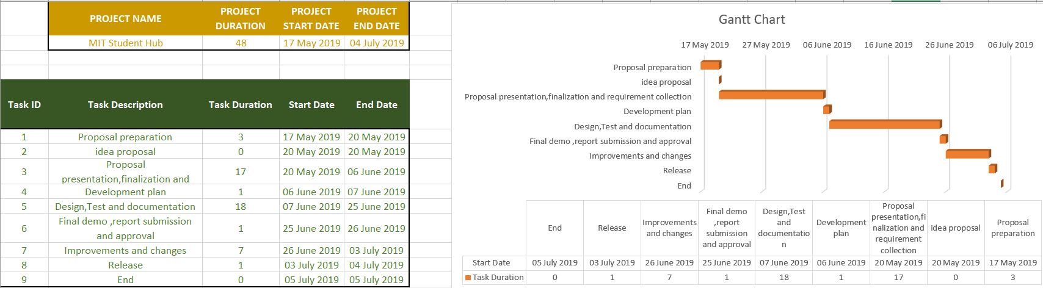

# Work Breakdown Structure

|  |  |  |  |
| --- | --- | --- | --- |
| **Task** | **Dates** | **Task Breakdown** | **Workload** |
| Programming | 27.05.19 – 26.06.19 | Using ASP.NET MVC(C#) and HTML BOOTSTRAP within the Visual studio to design and code the Graphical Use Interface, classes and methods which will ultimately produce the overall application. . | Amal with Tapan helping when required |
| Testing | 27.05.19 – 26.06.19 | We are doing the manual testing to test our multiple functionalities in the website. we faced some errors during the programming and we tried to handle and get rid of errors. | Amal and Tapan |
| Documentation | 27.05.19 – 26.06.19 | During the process of coding and testing , we have recorded each steps how our website functionalities works and we updated the Gannt chart and proposal as per the feedback provided by Dr Fadi. | Tapan and Kirpalpreet |
| Make necessary design changes and changes to the documentation | 21.06.19 – 26.06.19 | Depending on previous phases, we have made multiple changes and improvements in the design and also recorded in team meeting tables and updated our documents. | Amal and Tapan |
| Release final website | 26.06.19 – 27.06.19 | we have already made the changes to our final website and Ready for deploying. | Amal and Tapan |

# Navigation Diagram

Navigation diagram indicates all the functionalities entitled with our Mankau student hub website. When user opens the website, they need to login first and once after login they can access to all four activities that our website has.

# 

Fig 1: navigation diagram

# Use Case Diagram

Students website use case diagram is below: 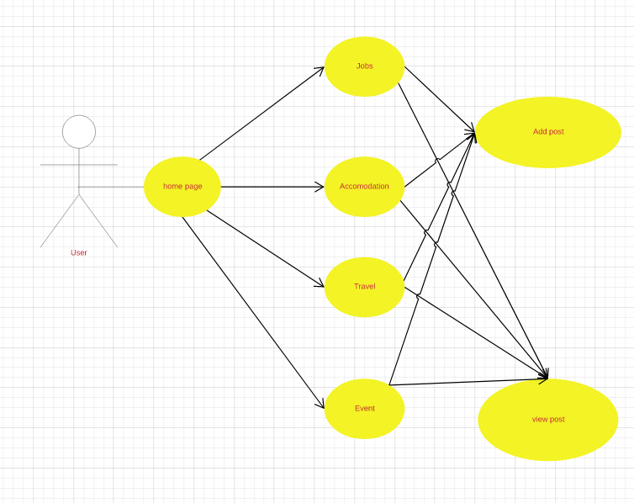

Fig 2: use case for student hub website

# Design and Analysis

* 1. **Login page**

We have designed a login page with only having a button for the MIT student access. We have whitelisted the access only for manukaumail.com domain in the access button which will provide access only to the person with an account in MIT manukau, which makes the website available only for MIT personalities.  
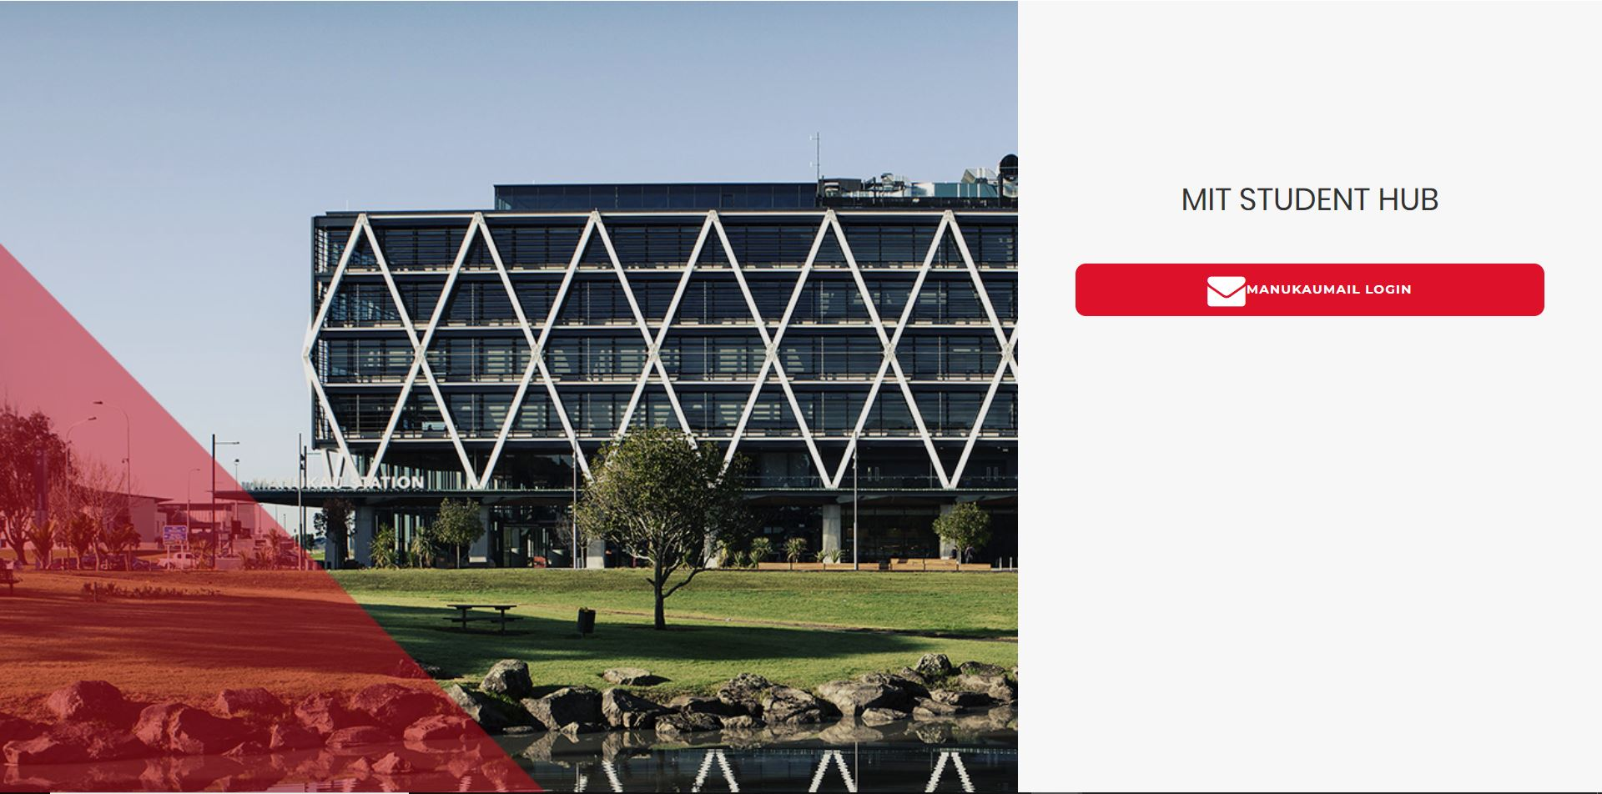

11.1.1Home page

A successful login will provide access to home page for the user. It is a landing page for the permitted accounts, which is having some common details and images. It can be used as a general description page and a photo gallery.



* + 1. Job, Accommodation, Travel, Events pages

This listed page has almost common features except the category of post can be done on each project. Main functionality of this pages is providing an option to add new ‘POSTS’ and showing it on the wall. Every posts of the user will be displayed on the page and an option to view all the posts of that particular category is also provided as a button, which will bring the user into a general listing page which list out all the posts according to the category in the descending order of the post.

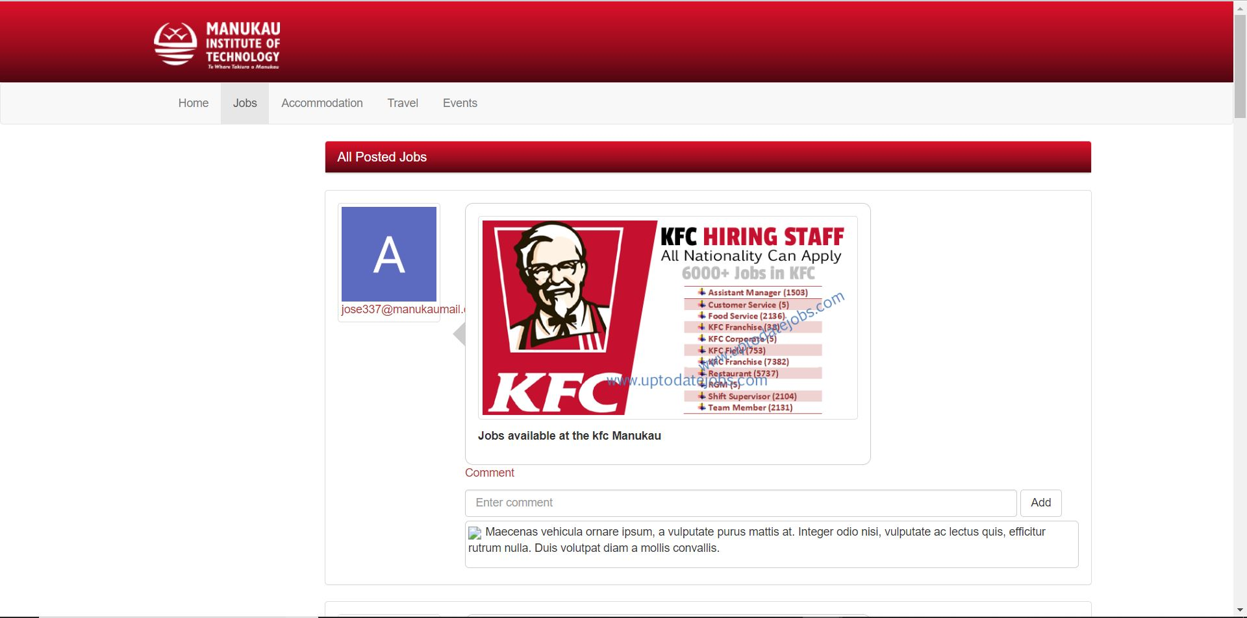

* + 1. Other features

A general navigation bar is provided in the top layout of the website which ease the movement from on page to another page different categories. comments for the particular posts can also be added within the wall. Comments for the specific post can be viewed underneath the posts.

# Implementation Phase

We have utilized different programming aspects and designing features to implement different sections of the project. Project is implemented in Asp.net MVC core. Microsoft Visual studio IDE has been utilised to code and design the project. It is the main tool used for the whole implementation phase. Any of the team members were familiar with the MVC core and it made a hurdle for our team to progress with the implementation. SQL server has been used for the database implementation. Local database has been setup with SQL server management studio to prototype the database. Visual studio helps to setup local iis server in order to run the prototype in local, which helped in coding and finding the errors.

As the most familiar design tools, HTML and Bootstrap has been chosen to proceed on the design phase.CSS is also used to improve the style and advance on the design pattern. JavaScript and jQuery libraries have a major impact on the coding besides the c#.

Trello was very helpful in handling the task and connect with the team members. It played an important role In order to follow the Gantt chart and the planned updates. diagrams were designed in Lucid chart, which is an easy usable and free software.

Microsoft word always play the important role in handling the proposal documentations and recording the important details on each phase of the project.

Design of the website is done at the first stage using HTML and Bootstrap. Different assets like logo and images regarding MIT were available online and we utilised it locally. Coding have been done according to the design requirements. Database design also done concurrently with the coding progress.

# Error Handling

Success of a software development lies on how the development team handles and solves the errors and bugs arise on different phases of the development. Coding phase of our project also faced lot of issues and risks. Moreover, an error, those hurdles were happened due to our lack of experience and shortage of document resources in internet regarding different implementations of the MVC core functionalities.

* Issue with storing images into database and retrieving the decoded image from database to mvc core.
* Rendering post details inside the posting details page.
* Rendering comments according to the posts.
* Handling the user corresponding details in the listing page.

Most of the issues were solved with the guidance and solutions found on csharpCorner and stack overflow websites which are established by experienced professionals. Referencing different solutions helped to fix a lot of problems. Time frame of the project restricted from implementing some more functionalities and the commenting option for the post. Lack of knowledge delayed the coding phase and error handling more challenging.

# Improvements and Future Considerations

Our proposed project was having limited scope and functionalities. Short time frame restricted us from adding more features in the project. We have considered a number of features to add and cut-off due to different difficulties. Lack of experience and the lack of knowledge of the team members also affected the options to improve the final product. Some of the suggestions to improve the website are the following.

## 14.1. Functionalities

Option to share the job details are not available in the website, which will be more helpful for students in sharing information to others. Feature to get notifications of the post can be included in the website to improve the easy findings of the particular post. Intercommunication between the members can be included by adding a chat functionality in the website, which will improve the usefulness and effectiveness of the website.

## 14.2 Design and Database

Current project database is narrow and the normalization of the database is not proper. Improving the normalization of the database will speed up the website and improve the response. We only considered narrow data set and the table structure is also not well enough to handle a powerful website. Design of the website is simple but it is mobile responsive and user friendly. However, improvements using different methods like implementation of react and angular js will improve the user experience as well as the data rendering problems in the completed project. Sorting option and paging feature could improve the listing pages and more user friendly.

# Conclusion

In conclusion we believe that our project had a great potential to become a success, which could offer demanding services to the students of MIT. Lack of knowledge and experience held back our project development phase. However, we succeeded in presenting a final product with completed functionalities we put forth as our objective in the starting stage. As the beginners to software development field, we come across different situations which challenged us to solve problems. Continues efforts and team work helped us to overcome the barriers. Future improvements in design and add-on functionalities can increase the relevance and need of our project. We believe that MIT student hub website can improve the life of the MIT students and offer perpetual services.

# Team Meetings

**Minutes of Meeting # 1 14/5/2019**

Meeting for making group and selection of the topic

|  |  |  |
| --- | --- | --- |
| **Agenda**  **Item** | **Description *– include a heading for each item recorded and a brief summary of the discussion.*** | ***Include the following four points:***   1. ***Action*** 2. ***Person responsible*** 3. ***Date action is to be completed*** |
| 1. | **Firstly we made a group of three members and discussed different topics to make a project for the hot topic.** | Amal,kirpal,Tapan |
| 2. | **Then with the help of the supervisor Fadi we have decided to make a Student hub website for the MIT.** | Amal,Tapan,Kirpal |
| 3 | **Then we discussed our ideas about the website. Which ideas we can add in this website** | Amal,Tapan,Kirpal |
| 4 | Our next meeting is decided for Next Tuesday | Amal,Tapan,kirpal |
| 5 | Close meeting: we have close our meeting at 2.30pm |  |

**Minutes of Meeting # 2 21/05/2019**

Meeting for making group and selection of the topic

|  |  |  |
| --- | --- | --- |
| **Agenda**  **Item** | **Description *– include a heading for each item recorded and a brief summary of the discussion.*** | ***Include the following four points:***   1. ***Action*** 2. ***Person responsible*** 3. ***Date action is to be completed*** |
| 1. | **Firstly we made a group of three members and discussed different topics to make a project for the hot topic.** | Amal,kirpal,Tapan |
| 2. | **Then with the help of the supervisor Fadi we have decided to make a Student hub website for the MIT.** | Amal,Tapan,Kirpal |
| 3 | **Then we discussed our ideas about the website. Which ideas we can add in this website** | Amal,Tapan,Kirpal |
| 4 | Our next meeting is decided for Next Tuesday | Amal,Tapan,kirpal |
| 5 | Close meeting: we have close our meeting at 2.30pm |  |

**Minutes of Meeting # 3**  *28/05/2019 2.00pm to 5.00pm*

**Chairperson: Amal**

**Present:**  All members are present

Listen lecture and Share ideas about our report

|  |  |  |
| --- | --- | --- |
| **Agenda**  **Item** | **Description *– include a heading for each item recorded and a brief summary of the discussion.*** | ***Include the following four points:***   1. ***Action*** 2. ***Person responsible*** 3. ***Date action is to be completed*** |
| 1. | **Attend the Fadi’s lecture about the Literature report** | Amal,Kirpalpreet,Tapan |
| 2. | **Also preparing the things explain in the Next presentation** | Amal,Kirpal,Tapan |
| 3 | **Focus on the Literature which we needed for our website and share ideas to each other** | Amal,kirpal,Tapan |
| 4 | Date of Next meeting is 23/5/2019 |  |
| 5 | Close meeting: 5.00pm |  |

**Minutes of Meeting # 4** *04/06/2019 2.00pm to 5.00pm*

**Chairperson: Amal**

**Present:**  All members are present

Listen lecture and Share ideas about our report

|  |  |  |
| --- | --- | --- |
| **Agenda**  **Item** | **Description *– include a heading for each item recorded and a brief summary of the discussion.*** | ***Include the following four points:***   1. ***Action*** 2. ***Person responsible*** 3. ***Date action is to be completed*** |
| 1. | **Attend the Fadi’s lecture about the Literature report** | Amal,Kirpalpreet,Tapan |
| 2. | **Also preparing the things explain in the Next presentation** | Amal,Kirpal,Tapan |
| 3 | **Focus on the Literature which we needed for our website and share ideas to each other** | Amal,kirpal,Tapan |
| 4 | Date of Next meeting is 23/5/2019 |  |
| 5 | Close meeting: 5.00pm |  |

**Minutes of Meeting # 4** *11/06/2019 2.00pm to 5.00pm*

**Chairperson: Amal**

**Present:**  All members are present

Listen lecture and Share ideas about our report

|  |  |  |
| --- | --- | --- |
| **Agenda**  **Item** | **Description *– include a heading for each item recorded and a brief summary of the discussion.*** | ***Include the following four points:***   1. ***Action*** 2. ***Person responsible*** 3. ***Date action is to be completed*** |
| 1. | **Attend the Fadi’s lecture about the Literature report** | Amal,Kirpalpreet,Tapan |
| 2. | **Also preparing the things explain in the Next presentation** | Amal,Kirpal,Tapan |
| 3 | **Focus on the Literature which we needed for our website and share ideas to each other** | Amal,kirpal,Tapan |
| 4 | Date of Next meeting is 23/5/2019 |  |
| 5 | Close meeting: 5.00pm |  |

**Minutes of Meeting # 6** *18/6/2019 2.00pm to 5.00pm*

**Chairperson: Amal**

**Present:**  All members are present

Listen lecture and Share ideas about our report

|  |  |  |
| --- | --- | --- |
| **Agenda**  **Item** | **Description *– include a heading for each item recorded and a brief summary of the discussion.*** | ***Include the following four points:***   1. ***Action*** 2. ***Person responsible*** 3. ***Date action is to be completed*** |
| 1. | **Attend the Fadi’s lecture about the Literature report** | Amal,Kirpalpreet,Tapan |
| 2. | **Also preparing the things explain in the Next presentation** | Amal,Kirpal,Tapan |
| 3 | **Focus on the Literature which we needed for our website and share ideas to each other** | Amal,kirpal,Tapan |
| 4 | Date of Next meeting is 23/5/2019 |  |
| 5 | Close meeting: 5.00pm |  |

# References

(2019). Retrieved from IT Knowledge portal: http://www.itinfo.am/eng/software-development-methodologies/

acodez. (2019). *12 BEST SOFTWARE DEVELOPMENT METHODOLOGIES WITH PROS AND CONS*. Retrieved from https://acodez.in/12-best-software-development-methodologies-pros-cons/

*acorn university* . (n.d.). Retrieved from https://www.acorn.utoronto.ca/

Archane, E. M. (2019). Retrieved from c-sharpcorner: https://www.c-sharpcorner.com/article/comments-system-with-asp-net-mvc-5-and-jquery2/

Ltd, C. A. (2019). Retrieved from ecanarys: https://www.ecanarys.com/Blogs/ArticleID/310/Implementing-Google-account-authentication-in-ASP-NET-MVC

*massey univesity* . (n.d.). Retrieved from http://www.massey.ac.nz/

*MSU denver university* . (n.d.). Retrieved from https://msudenver.edu/studenthub/

*ottago student hub*. (n.d.). Retrieved from ottago polytechnique : https://www.op.ac.nz/hub/

*Overview of ASP.NET Core MVC*. (2019). Retrieved from https://docs.microsoft.com/en-us/aspnet/core/mvc/overview?view=aspnetcore-2.2

Pandit, N. (2019). *how-to-configure-google-sign-in-for-Asp-Net-mvc-5-part-sixt*. Retrieved from c-sharpcorner: https://www.c-sharpcorner.com/article/how-to-configure-google-sign-in-for-Asp-Net-mvc-5-part-sixt/

*queen marry* . (n.d.). Retrieved from https://www.qmsu.org/offices/suh/

*University of torento*. (2019). Retrieved 06 2019, from University of toronto: https://www.acorn.utoronto.ca/index.php

*wikipedia*. (n.d.). Retrieved from https://en.wikipedia.org/wiki/Microsoft_SQL_Server